

**DRIVER DROWSINESS DETECTION SYSTEM**

**Design & developed by**

T.Abhinay 2111CS050068

D.Nikhil Kumar 2111CS050113

R.Pavan 2111CS050092

J.Aryan 2111CS050070

**GUIDED BY**

# Mrs.Affrose(Assi. Prof.)

**Department of Computer Science & Engineering**

**(INTERNET OF THINGS)**

**IIIYR-ISEM**

**Malla Reddy University, Hyderabad**

**2020-2025**



# CERTIFICATE

This is to certify that this is the bonafide record of the application development entitled “**DRIVER DROWSINESS DETECTION SYSTEM”**, submitted by **T.Abhinay (2111CS050068),D.Nikhil (2111CS050113), R.Pavan (2111CS050092), J.Aryan(2111CS050070)**

B. Tech III year I semester, Department of CSE (IOT) during the year 2022-23. The results embodied in this report have not been submitted to any other

university or institute for the award of any degree or diploma.

**Internal Guide Head of the department**  **Mrs.Affrose(Assi. Prof.) Dr.G.Anand Kumar**

**CSE(IOT)**

## External Examiner

**ACKNOWLEDGEMENT**

We would like to express our gratitude to all those who extended their support and suggestions to come up with this software. Special Thanks to our mentor **Mrs.Affrose** whose help and stimulating suggestions and encouragement helped us all time in the due course project development.

We sincerely thank our Head of the Department **Dr.G.Anand Kumar** for his constant support and motivation all the time. A special acknowledgement goes to a friend who enthused us from the backstage. Last but not the least our sincere appreciation goes to our family who has been tolerant, understanding our moods and extending timely support.

**ABSTRACT**

Drowsy driving is one of the leading causes of traffic accidents all over the world. Driving in a monotonous manner for an extended amount of time without stopping causes tiredness and catastrophic accidents. Drowsiness has the potential to ruin many people's lives. As a result, a real-time system that is simple to create and configure for early and accurate sleepiness detection is required. In this study, a real-time vision-based system called Driver Drowsiness Detection System has been developed utilizing machine learning.It is a project built using Dlib and OpenCV with Python as a backend language.The project includes direct working with the 68 facial landmark detector and also the face detector of the Dlib library. The 68 facial landmark detector is a robustly trained efficient detector which detects the points on the human face using which we determine whether the eyes are open or they are closed.

**INDEX**

**Contents Page No.**

Chapter 1 Introduction 01-03

1.1 Introduction 01

1.2 Purpose 02

1.3 Problem Statement 02-03

Chapter 2 Literature Review 04-05

Chapter 3 Project Description 06-10

3.1 Methodology 06

3.2 Work in Detail 07-08

3.3 Components 08

3.4 Facial landmark marking 09

3.5 Algorithm 10

Chapter 4 Implementation and Analysis 09-12

4.1 Code 11-14

Chapter 5 Results & Conclusion 15-17

5.1 Results 15

5.2 Conclusion 16

5.3 Future Work 16

5.4 References 16-17

**CHAPTER - 1**

## INTRODUCTION

**1.1 Introduction**

The development of technology allows us to introduce more advanced solutions in standard of living. As Per the info provided by NHTSA each year about 100,000 crashes get reported involving drowsy driving. The exact figure would be far more. Facial expressions can offer deep insights into many physiological conditions of the body. There are innumerable number of algorithms and techniques available for face detection which is the fundamental commencement within the process. Drowsiness in humans is characterized by some very specific movements and facial expressions- e.g.- the eyes begin to shut. To encounter this worldwide problem, an answer is tracking eyes to detect drowsiness and classify a driver drowsy. For real time application of the model, the input video is acquired by mounting a camera on the dashboard of the car and capturing the driver’s face. The Dlib model is trained to spot 68 facial landmarks, from which the drowsiness features are extracted, and the driver is alerted if drowsiness is detected.

This transformative project embodies the synergy between technological innovation and human well-being. With drowsy driving accounting for a staggering number of accidents, the convergence of cutting-edge technology and behavioral analysis becomes paramount. The approach involves real-time video acquisition through a strategically placed dashboard camera, granting a comprehensive view of the driver's facial expressions. The utilization of the Dlib model, proficient in discerning 68 facial landmarks, forms the bedrock of this initiative. These landmarks serve as a rich source of data, enabling the extraction of nuanced features indicative of drowsiness. As the eyes, often the gateway to fatigue, exhibit characteristic movements such as gradual closure, the system becomes attuned to these subtle cues. The integration of machine learning algorithms facilitates the automated classification of drowsiness, allowing for swift and proactive alerts to the driver. Beyond the immediate safety implications, this project exemplifies the potential of technology to safeguard lives and elevate the overall quality of our daily experiences on the road. As society hurtles towards an automated and interconnected future, initiatives like these underscore the responsibility and capability of technology to address pressing societal challenges.

This groundbreaking initiative at the intersection of technology and road safety not only responds to the alarming statistics surrounding drowsy driving but also underscores the power of artificial intelligence in shaping a safer automotive landscape. The project's emphasis on facial expression analysis and the deployment of sophisticated algorithms for face detection highlights a nuanced understanding of human physiology. By training the Dlib model to recognize 68 facial landmarks, the system gains an intricate understanding of the driver's expressions, transcending mere eye tracking. This nuanced approach allows for the extraction of multi-dimensional drowsiness features, offering a more robust and accurate detection mechanism. Moreover, the real-time nature of the application, facilitated by a dashboard-mounted camera, ensures a proactive response to the evolving state of the driver. The potential impact extends beyond accident prevention, delving into the realm of public health and well-being. As this project paves the way for a safer driving experience, it sets a precedent for the integration of artificial intelligence in addressing complex societal issues, marking a significant stride towards a safer and technologically empowered future.

**1.2 Purpose**

The implementation of a driver drowsiness detection system using machine learning, OpenCV, and dlib serves the purpose of enhancing road safety by addressing the issue of driver fatigue and drowsiness. Here are the key purposes for such a system:

* **Preventing Accidents:** One of the primary purposes is to prevent accidents caused by drowsy driving. Fatigue can impair a driver's reaction time, attention, and decision-making skills, leading to an increased risk of accidents. A drowsiness detection system can alert the driver or trigger safety mechanisms to prevent potential collisions.
* **Improving Road Safety:** By detecting signs of driver drowsiness, the system contributes to overall road safety. It can intervene when necessary, helping to reduce the number of accidents caused by tired or sleepy drivers.
* **Real-time Monitoring:** The system continuously monitors the driver's behavior and facial expressions in real-time. This allows for immediate response and intervention if signs of drowsiness are detected, contributing to proactive safety measures.
* **Adaptive Alerts:**The system can provide adaptive alerts based on the level of detected drowsiness. For example, it may start with gentle reminders, such as audible alerts or seat vibrations, and escalate to more intrusive measures if the drowsiness persists, like activating emergency lights or sending alerts to authorities.
* **User-Friendly Interface:** Implementing the system using OpenCV and dlib allows for the creation of a user-friendly interface. This can include visualizations of the driver's state, such as real-time video feeds or graphical representations, making it easier for both the driver and system administrators to understand and respond to the information.
* **Integration with Vehicle Systems**: The drowsiness detection system can be integrated with other vehicle systems, such as cruise control or lane-keeping assist, to further enhance safety. Integration with these systems allows for a more comprehensive approach to accident prevention.
* **Data Collection for Analysis:**The system can collect data on driver behavior and drowsiness patterns over time. This data can be valuable for analysis and research, leading to a better understanding of the factors contributing to driver fatigue and the development of more effective safety measures.
* **Compliance with Regulations:** In some regions, there may be regulations or guidelines encouraging or mandating the implementation of driver monitoring systems for commercial vehicles. Implementing a drowsiness detection system helps vehicle owners and operators comply with such regulations.

### Problem Statement

* **Drowsy Driving is a Big Problem:**

Lots of car crashes happen because drivers get really tired, especially during long and boring drives.Driving for a long time without a break makes drivers super tired, and that's when the chances of really bad accidents go up.

* **People's Lives Are in Danger:**

Drowsy driving doesn't just mean more accidents; it means real people getting hurt or even losing their lives.When drivers are too tired, the accidents they cause don't just affect them—it's a big problem for everyone on the road.

* **We Need to Catch Sleepiness Early:**

It's super important to notice when a driver is getting too tired early on.If we can tell when a driver is starting to feel really sleepy, we can help them before something really bad happens.

* **Using Smart Technology to Solve the Problem:**

Our project is all about using smart computer stuff to stop accidents from tired driving.We're using special computer programs (like Dlib and OpenCV) to teach the computer to recognize when a driver is too sleepy.

* **Making Sure It Works Right and Everyone Can Use It:**

The tricky part is making our system really good at telling if someone is sleepy, but also making it easy for everyone to use.It's not just about being smart; it's about being helpful for regular people so we can stop accidents caused by tired drivers.

* **Variability in Signs of Sleepiness:**

Highlight the variability in individual expressions of drowsiness. People may exhibit different signs when they are getting tired, making it essential for the system to be adaptive and capable of recognizing diverse cues.

**CHAPTER - 2**

## LITERATURE REVIEW

A lot of research is done in the field of driving safety to reduce the number of accidents. Following work was referred to for the study of the proposed system.

S. Kailasam [1] in his paper has designed a system that monitors the driver’s face from when the car starts. This mainly helps us to completely monitor the driver’s eye blinking and observe it continuously. They used a speed control system to check the speed of the car and the face image of the driver was being checked using a camera which was already fixed in front of him to alert the driver if they slowed down. It contains two parts: Working of Night vision camera and Prediction of Eye Blinking rate. This research shows the drowsiness detection and controls the accidents from increasing. If the vehicle is found to be speeding, the control system successfully sends information to the speedometer and thus it reduces to the random speed.

V. Shrivastava [2] in his paper has desiged a system with the objective to process images produced by monitoring drivers passively and using it to extract facial features and detect signs of distraction. An important feature of this system is real-time analysis for alerting drivers and avoiding accidents caused by distracted driving. The parameter used for making decisions about distraction is pupil. Using PERCLOS to detect distraction. The proposed algorithm is implemented in which current and ideal position of pupil is detected. Gaze is estimated based on the difference between distance from current pupil position and ideal pupil position to eye corner. The algorithm has been implemented considering the frontal face images. The accuracy obtained for the gaze detection was around 75-80%.

B. K. Rajan [3] in his paper focuses on building a system which detects more accurately and precisely the fatigue condition of the driver. This system is based on image processing. Compared to vehicle based and physiological signal-based techniques image-based technique is more secure and easy to implement. In this method, drowsiness was detected based on two conditions. The condition is checking the duration of blink and the next is counting the eye blink. The face was detected and tracked using a combination of viola jones and KLT algorithm. Viola-Jones algorithm will detect the object if the object is not moving During driving when there occurs any variation in the posture of it will adversely affect face detection. So, the KLT feature tracker is used to record the attributes in the detected face. The proposed methodology gives a new method to determine the weak condition of the driver and alert them when they start to fall asleep. By this idea, the number of accidents can be reduced, and it will confirm a safe journey.

J. Manikandan [4] in his paper focuses on tracking theeyes and mouth to detect drowsiness and classify a driver as drowsy. For real time application of the model, the input video was acquired by mounting a camera on the dashboard of the car and can accommodate the driver’s face, hands, upper body and occlusions such as non-tinted spectacles. For real- time application of the model, the input video can be acquired by mounting a camera on the dashboard of the car and can accommodate the driver’s face line the Dlib approach, the library’s pre-trained 68 facial landmark detector is used. Face detector which is based on Histogram of Oriented Gradients (HOG) was implemented. The proposed algorithm was the Eye Aspect Ratio (EAR) to monitor the driver’s blinking pattern and Mouth Aspect Ratio (MAR) to determine if the driver yawned in the frames of the continuous video stream. The results of real-time detection are lower as the model currently works exceedingly well under good to perfect light conditions like those found in the dataset videos, whereas the real-time testing was performed under a variety of lighting conditions. Various real time testing can be also performed under a variety of lighting conditions.

P. Kanani, [5] in his paper focuses on a System Capable to perform various tasks such as analysing alertness of the driver, detection of the car lane changes, detection of alcohol, calculating proximity of the objects on the road, analysing sentiments of the driver. In the cases where the driver needs to be alerted regarding the situation, an alarm is played. The proposed solution, Drowsiness of the driver is predicted with the help of EAR (Eye Aspect Ratio). In Real Time Eye Blinking Using Facial Landmarks A pre-trained Histogram of Oriented Gradients + Linear Support Vector Machine Object Detector for Facial Detection is utilized. The prototype accurately detected various cars, a person as well as a stop sign. The system prevents the engine from starting if the alcohol sensor detects the alcohol level to be higher than the permitted levels. The prototype accurately detected various cars, a person as well as a stop sign shows the detection of a car.

V. Nagarajan [6] in his paper focuses on building a system based on Viola and Jones' method. It detects faces of humans in three ways vertically, horizontally and rectangular. The system is used to design the camera and thus the points are directed towards the driver's face and monitor the eye closure of the driver to distinguish the fatigue or drowsiness of the driver. The Viola- jones method is used to segment the face and eye of the person from the camera. Then PERCLOS is used to detect the eye closure. The ADA Boost and Viola- jones are used for rejection cascading. The present study states the drowsiness in drivers while travelling and which is the major cause for the accidents. In this paper the concept of Viola- Jones method is used. The eye closure is having three states open, closed, partially closed. If the driver’s eyes are closed means the alarm/warning signal is given to the driver.

**CHAPTER - 3**

**PROJECT DESCRIPTION**

**3.1 Methodology**

The suggested method for detecting tiredness in drivers operates on two levels. The procedure begins with the camera recording live video frames, which are then transferred to a local server. The Dlib library is utilised on the server to identify facial landmarks, and a threshold value is used to determine whether or not the driver is sleepy. The EAR (Eye Aspect Ratio) is then computed using these face landmarks and given to the driver. The EAR value obtained at the application's end is compared to a threshold value of 0.25 in our system. The driver is regarded to be sleepy if the EAR value is less than the threshold value. An alarm would then sound, alerting the driver and passengers.

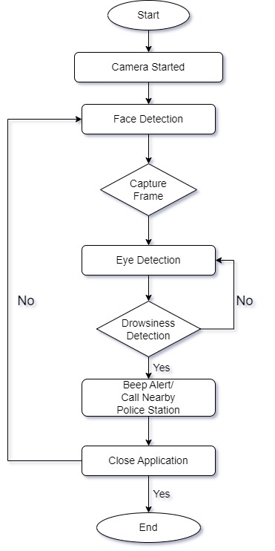

**Fig 3.1**

**3.2 Work in detail**

**Video Input:**

The project commences by capturing a continuous video feed from the device's camera. This crucial step is facilitated through OpenCV, a powerful computer vision library widely acclaimed for its versatility in handling video streams.

**Face Detection:**

Employing the Dlib library, the system employs a frontal face detector to identify and locate faces within the frames of the video stream. This involves precise coordinate identification of the bounding box encapsulating the detected face, laying the groundwork for subsequent analysis.

**Facial Landmark Detection:**

Once a face is successfully detected, the project leverages the Dlib's 68-point facial landmark detector. This sophisticated module accurately identifies and marks 68 specific points on the face, encompassing critical areas such as eyes, nose, and mouth. These landmarks serve as the foundation for detailed facial expression analysis.

**Blink Analysis:**

The system moves on to blink analysis, a pivotal component of drowsiness detection. The blink ratio is calculated by assessing the proportion of eye closure to eye opening. This numerical representation allows the system to discern whether the driver's eyes are open, closed, or in a transitional state. The blinked() function intricately computes this ratio based on the distances between key facial landmarks.

**Classification:**

Building on the blink analysis, the system classifies blinks into three distinct categories: active blinks, drowsy blinks, and prolonged eye closures indicative of potential sleepiness. This categorization sets the stage for a nuanced understanding of the driver's alertness levels.

**Status Determination:**

The project keeps a vigilant track of consecutive occurrences of different blink states over time. If a predefined threshold is surpassed, the system updates the driver's status accordingly, providing a dynamic reflection of their current level of alertness.

**Display and Feedback:**

To facilitate real-time communication with the user, the system overlays a status message directly onto the video feed. This immediate feedback informs the driver of their current state, with messages such as "Active :)", "Drowsy !", or "SLEEPING !!!" dynamically changing based on the analysis.

**Result Display:**

Additionally, the system generates a dedicated display window that visually represents the detected face, complete with annotated landmarks and the bounding box. This visual aid enhances transparency, allowing users to comprehend and validate the ongoing detection process.

**User Interaction:**

The system maintains an interactive loop, continually updating the display and awaiting user input for program termination. This user-friendly approach ensures that the application seamlessly integrates into the driving experience, prioritizing safety without compromising user control

**3.3 Components**

For drowsiness detection we have used OpenCV and Python. The Dlib library is used to detect and isolate the facial landmarks using Dlib pre-trained facial landmark detector. In this approach, 68 facial landmarks have been used.

* **OpenCV**

OpenCV, or Open Source Computer Vision Library, is a comprehensive open-source computer vision and machine learning software library. It provides a vast array of tools and functions that enable developers to work with images and videos, offering solutions for various computer vision tasks. Developed in C++ and equipped with Python bindings, OpenCV supports multiple platforms, including Windows, Linux, macOS, Android, and iOS, making it versatile for a wide range of applications. The library encompasses a rich set of functionalities such as image processing, feature detection, object recognition, machine learning, and camera calibration. OpenCV's modular structure allows users to seamlessly integrate its features into their projects, whether they involve robotics, augmented reality, medical imaging, or surveillance systems. With a strong emphasis on real-time performance and efficiency, OpenCV has become a go-to resource for researchers, developers, and engineers working in the field of computer vision, contributing significantly to advancements in image and video analysis across diverse domains.

* **dlib**

dlib is a comprehensive open-source software library primarily designed for machine learning, computer vision, and image processing tasks. Developed in C++, it offers a wide range of functionalities and tools that make it a powerful resource for various applications. One of its key features is its effectiveness in facial recognition, object detection, and landmark detection, allowing developers to build robust and accurate systems for tasks such as face identification and facial expression analysis. Dlib also provides tools for machine learning, including support for training and deploying complex models. Its versatility extends to image processing, offering utilities for image manipulation, filtering, and feature extraction. Moreover, dlib is known for its efficiency and speed, making it a popular choice in real-time applications. The library is well-documented and actively maintained, fostering a vibrant community of users and contributors. Overall, dlib's versatility, efficiency, and rich feature set make it a valuable resource for developers working on a broad spectrum of computer vision and machine learning projects.

**3.4 Facial landmark marking**

Dlib is a powerful library renowned for its facial landmark extraction capabilities, essential in applications like facial recognition and expression analysis. Its prowess lies in utilizing a pre-trained face detector, an enhanced version of the histogram of oriented gradients (HOG). The library features two shape predictor models, both trained on the i-Bug 300-W dataset, facilitating the localization of 68 and 5 landmark points within a facial image. In our method, we specifically leverage the 68 facial landmarks for detailed analysis.

The technique employed by Dlib involves constructing histograms based on the frequencies of gradient directions in localized regions of an image. This approach excels in describing contour and edge features, making it particularly effective for face detection and offering versatility across various objects.

To record facial landmarks, our system employs the Facial Landmark Predictor, utilizing its capabilities to calculate lengths for the Eye Aspect Ratio (EAR) values. This ratio is crucial in assessing facial expressions and eye behavior. The visual representation of facial landmark points provided by Dlib is instrumental in our computation of EAR.

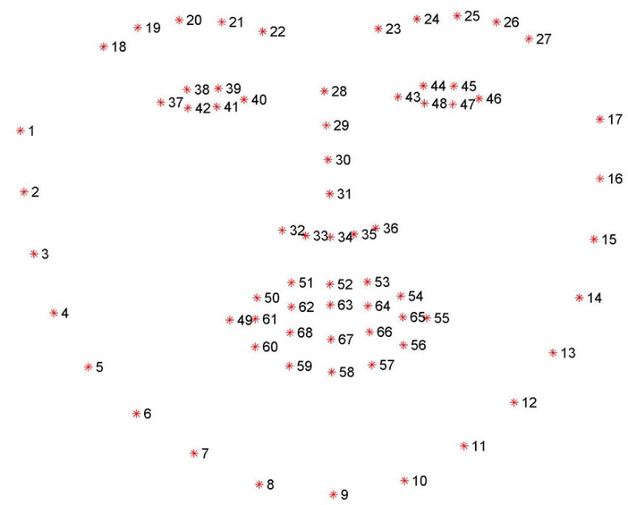

**Fig 3.4**

**3.5 Algorithm**



**Fig 3.5.1**

Here P1, P2, P3, P4, P5, P6 are the pupil coordinates EAR is generally a constant when eyes are open and is near about 0.25. When EAR is between 0.25 and 0.21 It is concluded that Person is drowsy. When EAR is less than 0.21 It is concluded that Person is sleeping.

Eye Aspect Ratio(EAR) is calculated for both the eyes,

(|P2 − P6| + |P3 − P5|)

_______________________________

2(|P1 − P4|)

The numerator determines the distance between the upper and lower eyelids using equation 1. The horizontal distance of the eye is represented by the denominator. EAR values are utilised to identify driver sleepiness in this framework. The average of the EAR values of the left and right eyes is obtained. The Eye Aspect Ratio is watched in our sleepiness detection system to see whether the value falls below the threshold value and does not climb over the threshold value in the following frame. The individual has closed their eyes and is sleepy, as indicated by the aforementioned circumstance. In contrast, if the EAR value rises again, it means that the person is simply blinking his eyes and is not drowsy

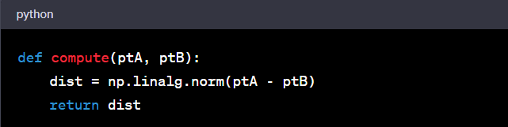

**Fig 3.5.2 Computes the Euclidean**

**distance between two points**

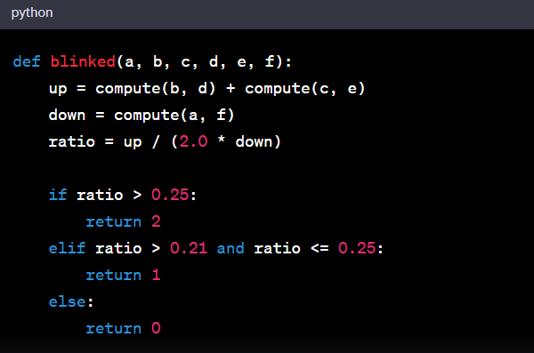

**Fig 3.5.3 Determines the blink type**

**based on the calculated blink ratio.**

**CHAPTER-4**

**IMPLEMENTATION AND ANALYSIS**

**4.1 CODE**

import cv2

import numpy as np

import dlib

from imutils import face_utils

cap = cv2.VideoCapture(0)

detector = dlib.get_frontal_face_detector()

predictor = dlib.shape_predictor("shape_predictor_68_face_landmarks.dat")

sleep = 0

drowsy = 0

active = 0

status = ""

color = (0, 0, 0)

def compute(ptA, ptB):

dist = np.linalg.norm(ptA - ptB)

return dist

def blinked(a, b, c, d, e, f):

up = compute(b, d) + compute(c, e)

down = compute(a, f)

ratio = up / (2.0 * down)

if ratio > 0.25:

return 2

elif ratio > 0.21 and ratio <= 0.25:

return 1

else:

return 0

while True:

_, frame = cap.read()

gray = cv2.cvtColor(frame, cv2.COLOR_BGR2GRAY)

faces = detector(gray)

for face in faces:

x1 = face.left()

y1 = face.top()

x2 = face.right()

y2 = face.bottom()

face_frame = frame.copy()

cv2.rectangle(face_frame, (x1, y1), (x2, y2), (0, 255, 0), 2)

landmarks = predictor(gray, face)

landmarks = face_utils.shape_to_np(landmarks)

left_blink = blinked(landmarks[36], landmarks[37],

landmarks[38], landmarks[41], landmarks[40], landmarks[39])

right_blink = blinked(landmarks[42], landmarks[43],

landmarks[44], landmarks[47], landmarks[46], landmarks[45])

if left_blink == 0 or right_blink == 0:

sleep += 1

drowsy = 0

active = 0

if sleep > 6:

status = "SLEEPING !!!"

color = (255, 0, 0)

elif left_blink == 1 or right_blink == 1:

sleep = 0

active = 0

drowsy += 1

if drowsy > 6:

status = "Drowsy !"

color = (0, 0, 255)

else:

drowsy = 0

sleep = 0

active += 1

if active > 6:

status = "Active :)"

color = (0, 255, 0)

cv2.putText(frame, status, (100, 100), cv2.FONT_HERSHEY_SIMPLEX, 1.2, color, 3)

for n in range(0, 68):

(x, y) = landmarks[n]

cv2.circle(face_frame, (x, y), 1, (255, 255, 255), -1)

cv2.imshow("Frame", frame)

# Check if face_frame is defined before displaying it

if 'face_frame' in locals():

cv2.imshow("Result of detector", face_frame)

key = cv2.waitKey(1)

if key == 27:

break

cap.release()

cv2.destroyAllWindows()

**CHAPTER -5**

**RESULTS & CONCLUSION**

**5.1 Result:**

After successful compilation of the given code the results are as follows:

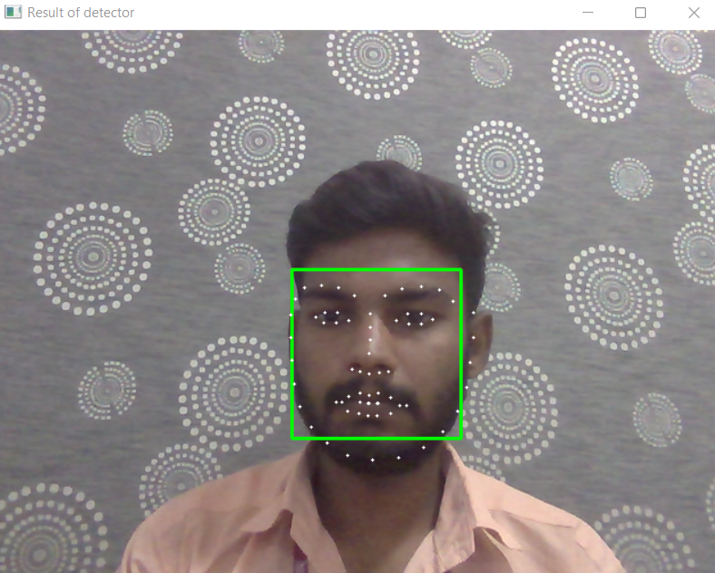 

**Fig 5.1.1: Shape Predictor-68 Face Fig 5.1.2: Person is Active :)**

**Landmarks**

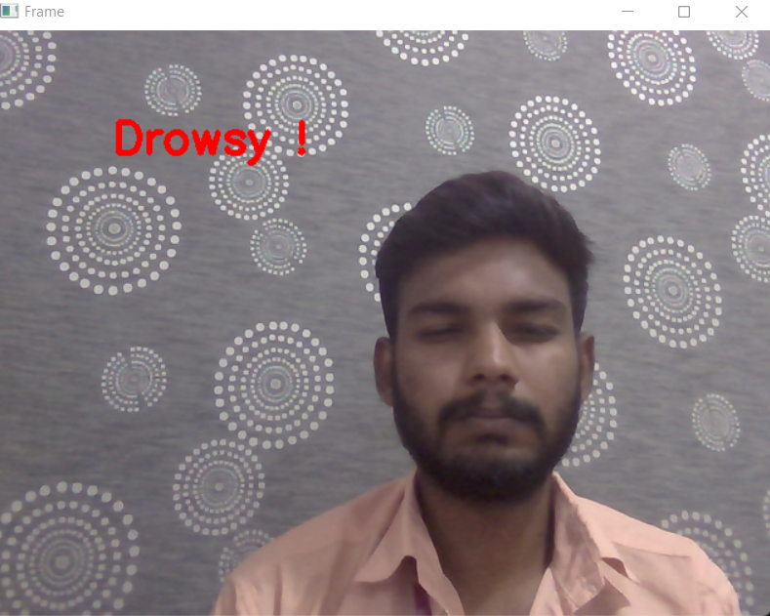 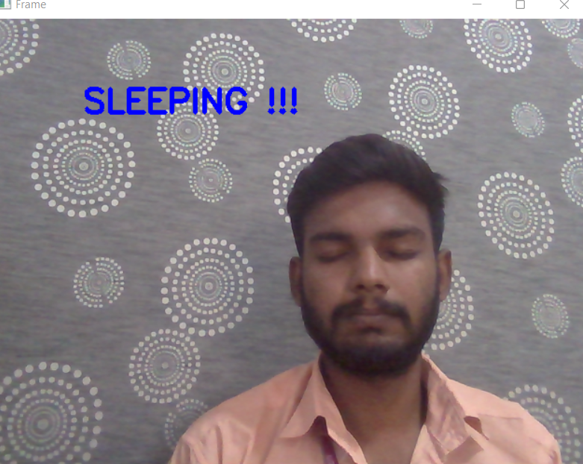

**Fig 5.1.3: Person is Drowsy ! Fig 5.1.4: Person is Sleeping !!!**

**5.2 Conclusion:**

In conclusion, the Driver Drowsiness Detection System represents a significant step forward in addressing the critical issue of drowsy driving. Through the integration of machine learning and vision-based techniques, this system provides a real-time, accurate, and easily implementable solution to detect early signs of driver fatigue.

By leveraging the power of facial landmarks and blink analysis, the system offers a non-intrusive means of monitoring driver alertness. The utilization of Dlib and OpenCV libraries, along with the 68-point facial landmark detector, demonstrates the effectiveness and robustness of this approach.

This project not only holds the potential to save lives by preventing accidents caused by drowsy driving but also contributes to the ongoing efforts to enhance road safety. The system's adaptability and scalability make it a valuable addition to the arsenal of technologies aimed at safeguarding individuals on the road.

**5.3 Future work:**

1. **Integration with Advanced Sensors:**

Explore the integration of additional sensors such as infrared cameras or EEG sensors to enhance the accuracy and reliability of drowsiness detection. These sensors can provide supplementary data for a more comprehensive assessment of the driver's alertness.

1. **Dynamic Environmental Adaptation:**

Investigate methods to adapt the system to different driving conditions, including variations in lighting, weather, and road conditions. This would ensure optimal performance across a wide range of real-world scenarios.

1. **Multi-Modal Data Fusion:**

Explore the potential of combining data from multiple sources, such as facial landmarks, physiological signals, and vehicle telemetry, to create a comprehensive driver monitoring system. This holistic approach may provide a more nuanced understanding of driver behavior.

1. **Real-Time Intervention Strategies:**

Develop mechanisms for real-time interventions to mitigate the risks associated with drowsy driving. This could include auditory or visual alerts, seat vibrations, or even automated adjustments to the vehicle's driving mode.

1. **Long-Term Driver Profiling:**

Implement techniques for long-term driver profiling to understand individual variations in drowsiness patterns. This could lead to personalized interventions and recommendations tailored to specific drivers.

**5.4 References**

[1] S. Kailasam, M. Karthiga, R. M. Priyadarshini, K. Kartheeban and K. Anithadevi, "Accident Alert System for Driver Using Face Recognition," 2019 IEEE International Conference on Intelligent Techniques in Control, Optimization and Signal Processing

[2] A. Walavalkar, S. Singh, R. Salian and V. Shrivastava, "Driver Distraction Monitoring and Alerting System," 2019 1st International Conference on Advances in Information Technology (ICAIT), Chikmagalur, India, 2019,

[3] H. Joseph and B. K. Rajan, "Real Time Drowsiness Detection using Viola Jones & KLT," 2020 International Conference on Smart Electronics and Communication (ICOSEC), Trichy, India

[4] S. Mohanty, S. V. Hegde, S. Prasad and J. Manikandan, "Design of Real-time Drowsiness Detection System using Dlib," *2019 IEEE International WIE Conference on Electrical and Computer Engineering (WIECON-ECE)*, Bangalore, India, 2019

[5] A. Raorane, H. Rami and P. Kanani, "Driver Alertness System using Deep Learning, MQ3 and Computer Vision," 2020 4th International Conference on Intelligent Computing and Control Systems (ICICCS), Madurai, India, 2020

[6] K. S. Sankaran, N. Vasudevan and V. Nagarajan, "Driver Drowsiness Detection using Percentage Eye Closure Method," 2020 International Conference on Communication and Signal Processing (ICCSP),Chennai, India, 2020

[7] K. S. Sankaran, N. Vasudevan and V. Nagarajan, "Driver Drowsiness Detection using Percentage Eye Closure Method," 2020 International Conference on Communication and Signal Processing (ICCSP),Chennai, India, 2020

[8] Ahmed, Javed et al. “Eye behaviour based drowsiness Detection System.” *2015 12th International Computer Conference on Wavelet Active Media Technology and Information Processing (ICCWAMTIP)* (2015): 268-272